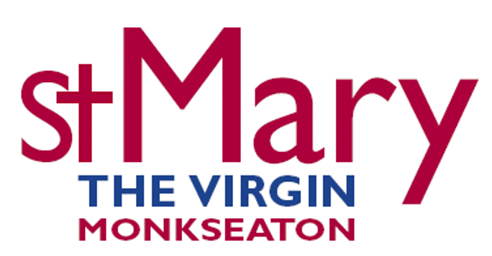 St Mary’s Toddler Group Terms and Conditions
Please read and agree to the following terms.
Our Toddler Group is aimed primarily at Toddlers aged 1-2 years old and their parents/carers, but can also accommodate babies, and some older children, especially if siblings are visiting together. We do not register new children who are already 3 years old. Once a child reaches their third birthday, we would allow them to complete the term in which that birthday falls but then we would ask that they leave our Toddler group to allow for a younger child from our waiting list to take that place. If this causes a problem, then please let us know. We are willing to listen to individual circumstances. We are not able to cater for any children aged 4 and above.
We are open on Monday each week during term time between 9.30 and 11am and again at 1.30pm until 3pm, inside the main church building, accessed via the main door, adjacent to the car park. Each session costs £3 for the first child, then 50p for additional children. We ask that you do not bring more than 2 children per adult, unless they are siblings. Please contact us if this causes any issues or concerns. We can offer only one session, either morning or afternoon and this is not interchangeable. For more information about waiting lists please contact stmarysmonkseatontoddlers@gmail.com
We like to ensure that every group member feels relaxed, supported, safe and secure, and that they have fun while we are here. For this reason, we monitor numbers regularly to make sure we have enough support. Spaces are in demand for our Toddler Group. If you do not attend for three weeks in a row without prior notice, we may offer your place to another family on the waiting list.
Your child’s safety and the way they relate to and play with other children, are your responsibility. Please supervise them closely during the session. Take care of and encourage your children to look after the church building, the equipment and each other, and take care with food and drinks, buggies and belongings. Please no food or drinks during the session, except for the refreshments provided (plus breast/bottle/tube feeding for infants). Parents/carers of those children with allergies are asked to check on the ingredients of the refreshments being offered or can bring their own refreshments if this is better for the child.
In order to help prevent the risk of the spread of infectious diseases, such as, but not limited to, coronavirus (COVID-19) there may be measures in place to which you may be asked to adhere. These could include encouraging washing or sanitising hands. Please bring only healthy children to the Toddler Group. You and your child should remain at home if they or you have had a fever, vomited, or had diarrhoea within the past 48 hours or are exhibiting contagious cold symptoms. We reserve the right to refuse admittance to the session if we feel that the child or adult is too ill to participate.
From time to time we may request to take photographs or shoot video during sessions to use for marketing and promotional purposes, which may include, but is not limited to, use on social media, promotional materials or our website. You will be asked at or prior to the first session, whenever this takes place, whether you consent to being included in these images or footage and images and usage will be in relation to our privacy policy that can be found on our website here: https://www.stmarysmonkseaton.org.uk/dataprivacy. Where images are used in this way no additional personal information or names will be linked to them, unless specific additional permission is sought from the individuals involved. We are happy for you to take photographs of your own child. If you wish for another child to be in the picture, please seek permission from the adult accompanying that child before taking pictures. We reserve the right to amend membership of the Toddler Group.
We reserve the right to update the terms and conditions.
St Mary’s Monkseaton, July 2023

